应用开发的过程与方法
命名方法详见《应用开发中的命名规则》

一、系统安装与环境配置

1.1 系统安装

1.1.1 VC＋＋

1.1.2 CATIA

1.1.3 组建应用接口（CAA）

1.1.4 快速应用开发环境（RADE）

1.2 应用开发环境配置

二、目录结构的建立

2.1 创建工作空间（Workspace）
In Microsoft Developer Studio open menu "File" and select "Open CAAV5 Workspace", the following window appears in which you can select to open your workspace with the "mkmk" functionalities.
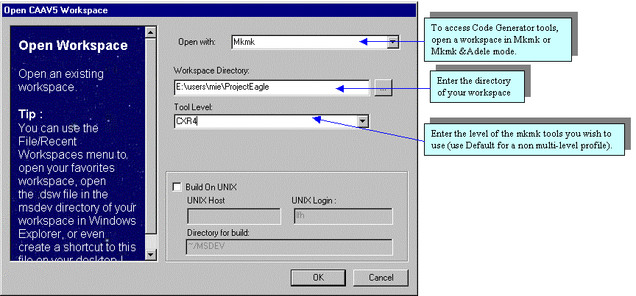
Either mode will give you access to the Code Generator features.
Once you have filled in the workspace information, click on "OK". A log window appears while your environment is updated and the workspace opened. When this window has disappeared Developer Studio loads the project files it stored in your workspace and you are ready to work.
The commands available in the Code Generator are a set of wizards wherein you specify a series of parameters and it will generate code for you. Before creating the code, a report window appears so that you may verify that the code generated is as you expect it.
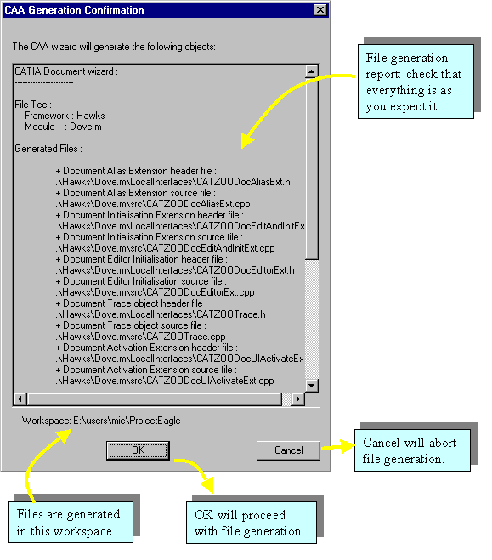
You may find that some of the generated source files contain commented out statements such as "DO NOT EDIT :: THE CAA2 WIZARDS WILL INSERT CODE HERE". Do not modify what you find between these commented lines or the wizards will no longer be able to insert code in the source file.

2.2 定义组件框架（CAA V5 Framework/Implementation Framework）
In Microsoft Developer Studio, open menu "Project" and select "New Framework…"
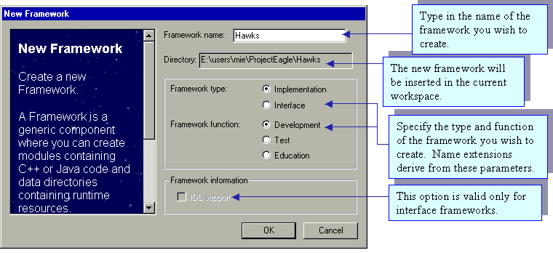
The wizard will then create the following directory structure:
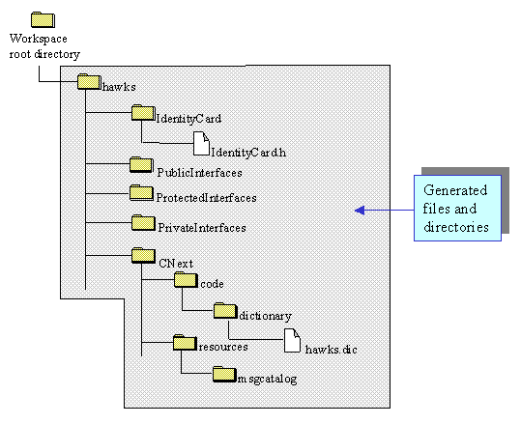
Education type frameworks are suffixed ".edu" and Test frameworks are suffixed ".tst". The wizard appends these suffixes to the name of the framework.

2.3 定义接口空间（Interface Framework）
An interface framework is a framework that contains (mainly) interfaces in both C++ or IDL language. The structure of this interface is very specific. V5 naming conventions requires that these interfaces be distinguishable through an "Interfaces" suffix. Therefore if you type in "Bird" in the framework name, the generated framework will be called "BirdInterfaces". The generated structure is the following:
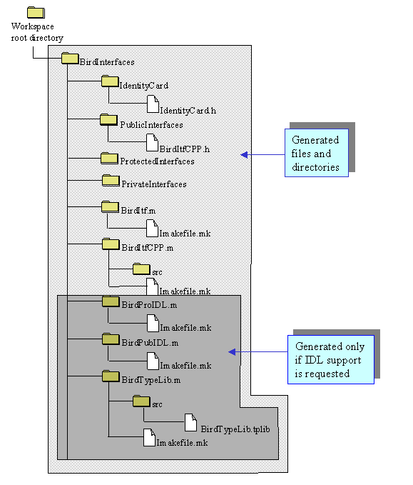
After the file structure has been created, the C++ Interactive Dashboard updates your Developer Studio project to take into account the new files and directories. In the Java Interactive Dashboard, you will see the new framework in the workspace tree view. Note that the framework is set as the currently active project.

2.4 定义模块（Module）
In Microsoft Developer Studio, open menu "Project" and select "New Module…"
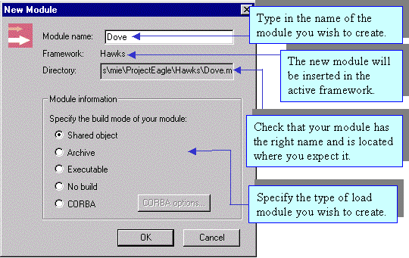
When you click on "OK" a report window is displayed to show you the files and directories that will be created. If you accept, the following file structure will be created:
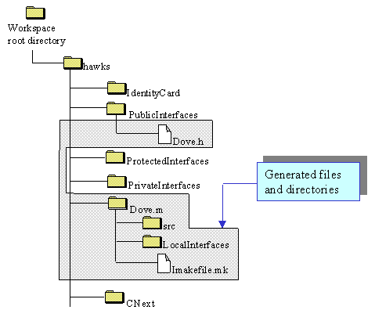
Note that the newly created module is set as the currently active module

三、类定义
Code Generator wizards enable you to create specific V5 objects that implement customary V5 patterns. These currently include:
- Object modeler interfaces (both C++ and IDL)
- Object modeler implementations
- V5 documents
- V5 features.
In Microsoft Developer Studio, source code is generated in the currently active module. If the active project is not a module, the following warning box will ask you to select an active module. In Microsoft Developer Studio, this is done by activating the contextual menu on the desired Microsoft project ("Set as active project"). | 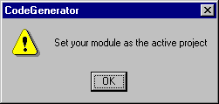
When you generate source code using the Code Generator, your workspace is updated to take into account the files newly created. In Developer Studio only, this often results in the following warning:
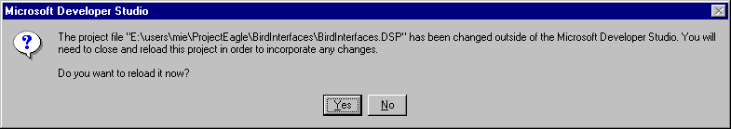
This is an expected behaviour and it is safe to reload your project.

3.1 CAA V5 C++类
In Microsoft Developer Studio, open menu "Insert" and select "CAA V5 Class..." .
It is recommended to use this command rather than using MsDev's own class creator because it takes into account the CAAV5 File Tree, as well as the standard macros included in the CAA classes.
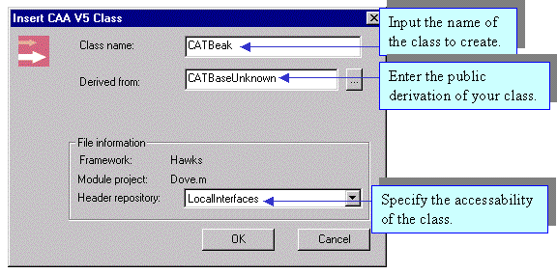
The wizard will create a header and a source file comprising a standard constructor and destructor, as well as an equal operator and a copy constructor. The following files are created.
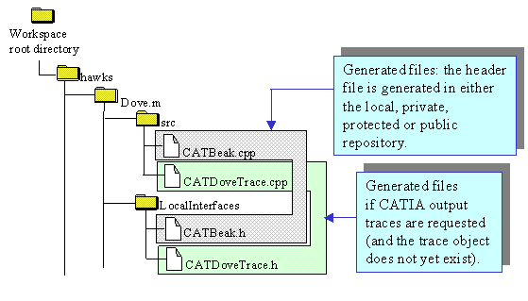

3.2元件接口类（Object Modeler interfaces）
Interfaces can be defined in C++ or in IDL (interface definition language).In Microsoft Developer Studio, open menu "Insert" and select "Interface..." .

3.2.1 C++接口
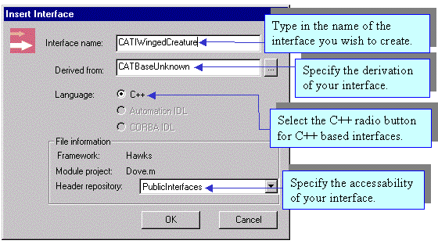
V5 naming conventions require that your interface have a 3 letter prefix, followed by the letter 'I' in upper case, followed by anything else, as in CATINavigateObject.
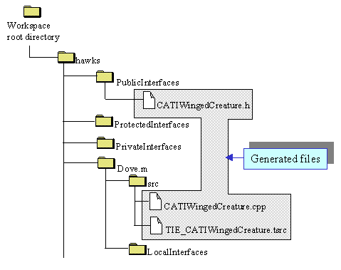

3.2.2 IDL接口
IDL interfaces can only be generated inside an Interface framework. The IDL radio button will be greyed out in any other type of framework.
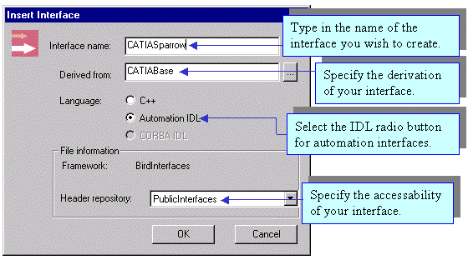
V5 naming conventions require that automation interface have a 3 letter prefix, followed by the letters IA in upper case, followed by anything else. The automation alias will be generated by extracting the XXXIA prefix from the interface name.
When you click on "OK" a report window is displayed to show you the files that will be created. If you accept, the following files will be created (or affected):
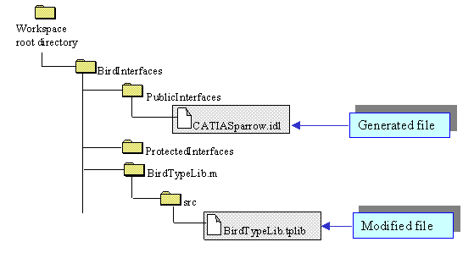

3.3元件实现类（Object Modeler Implementations）

3.3.1 定义新元件
Component implementations are written in C++. They cannot be included in interface frameworks...In Microsoft Developer Studio, open menu "Insert" and select "Component..."
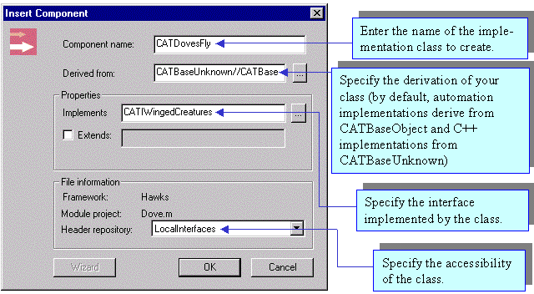
Even though you may create an implementation from either a C++ or an IDL interface, the wizard will not function on an uncompiled IDL header.
If you directly type in the name of the interface you wish to implement, the command will prompt you to specify the header file that contains the definition of the interface. You may also ask the wizard to list all of the available interfaces in your workspace, or in your prerequisite workspaces (this may take some time as it parses all the interfaces in the workspace).
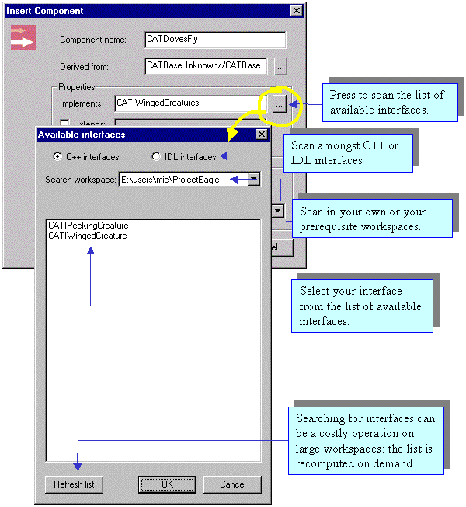
When you click on "OK" a report window is displayed to show you the files that will be created. If you accept, the following files will be created:
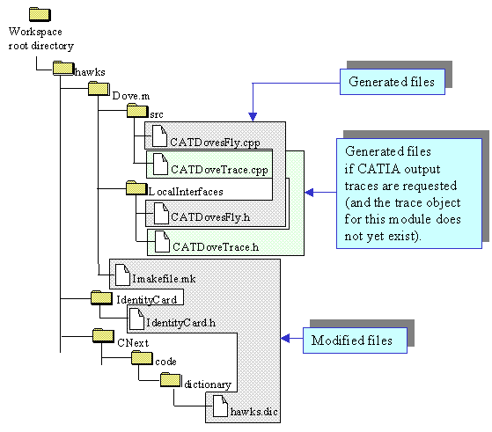

3.3.2 扩展现有元件
The previous command also allows you to add new extensions to already existing implementations. You do this by checking the item "Extends" and by specifying which object you are extending.
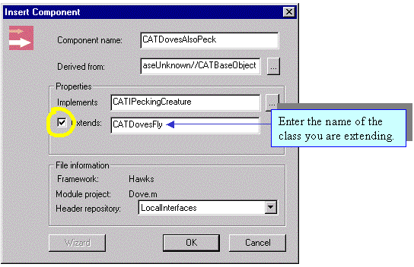
The generated objects for extensions are the same as for implementations.

3.3.3 利用元件实现类构造工具（Implementation Wizard）
When you develop a new implementation or extension, you may derive from another C++ class that already implements some of the functions of the interface you are implementing. As such, you have a choice between overloading those functionalites or not redefining them and using them as they have been defined in the base class. By default, the implementation builder will make you write all the methods of the interface. By using the wizard, you can choose between redefining those methods or not. (Of course, if the base class implements no method from the interface, using the wizard will not be of any use).
The wizard push button is available as soon as you type in a base class different from CATBaseUnknown or CATIABaseObject. The wizard will then scan the base class to find if it implements any methods of the interface and will display them in a list
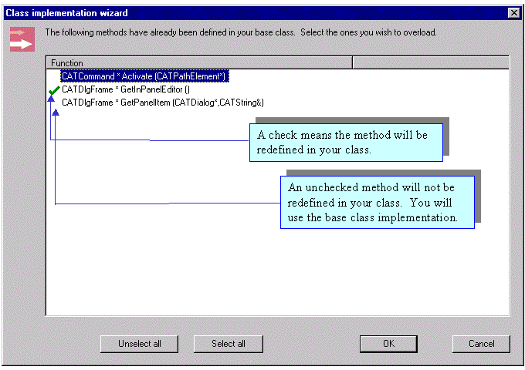

3.4命令类（command）
You may create several different types of new commands that you can add in your workshops:
In Microsoft Developer Studio, open menu "Insert" and select "CATIA Resource/Command..."
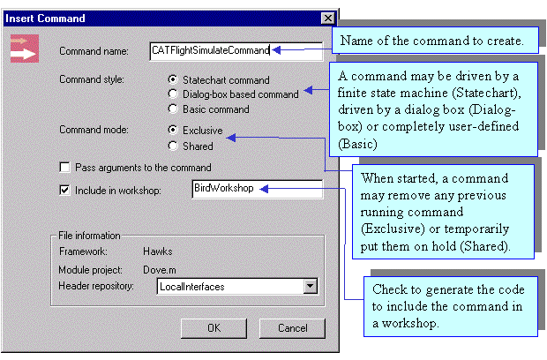
When specifying the name of a workshop (or workbench), the wizard will locate the code for that workshop and generate a command header for you. If no command header is found, a new type of header will be generated.
Even though you have selected the "Include in workshop:" check, you will still need to use the "Customize" functionality of CATIA to access the command from your palette.
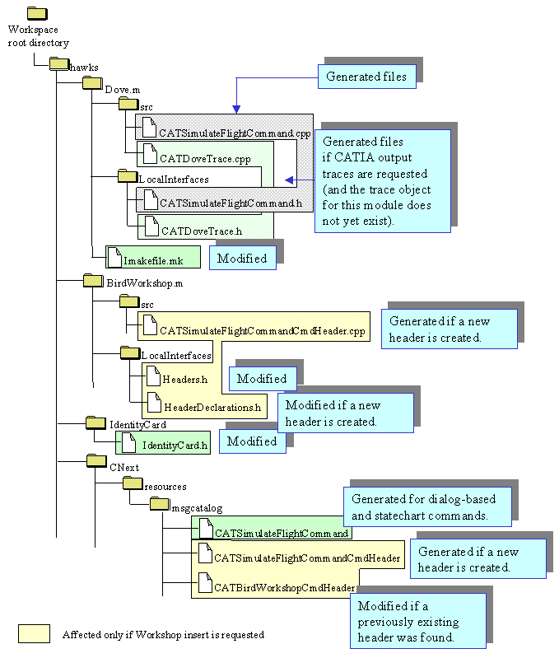

3.5 对话框类（Dialog Object）
You may create interactively a new dialog element based on the Dialog framework:
In Microsoft Developer Studio, open menu "Insert" and select "CATIA Resource/Dialog..."
Note that if you want to create a dialog-based command, you should use the " Command..." item of the "CATIA Resource" submenu of the "Insert" menu.
When you select this command, a new page is inserted in your MsDev environment with a new and empty dialog. Refer to " Dialog builder features" for full documentation. 此处不明白！！！

3.6测试实例（V5 Test-case）
You may create interactively a new test case script inside a test-dedicated framework by using:
In Microsoft Developer Studio, open menu "Insert" and select "Test-Case…"
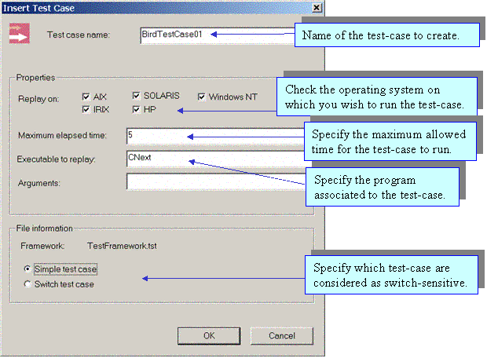
When you select this command, a new test case script is created in your framework. This test case can be run using the " Replay Test-Cases" command found in the "Build" menu.
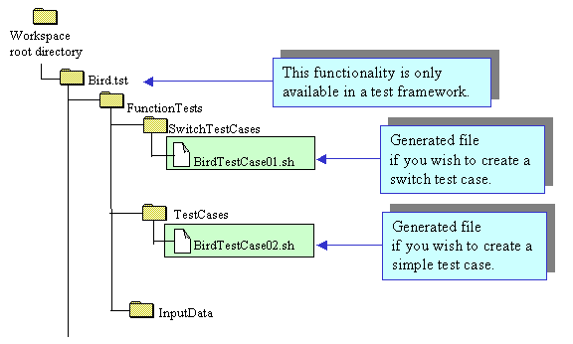

3.7交互界面（Workshop/Workbench）类
The component builder currently only allows you to generate one type of V5 pattern: Workshops (or workbenches)
In Microsoft Developer Studio, open menu "Insert" and select "CATIA Resource/CATIA Pattern..."
You must first select the type of component you wish to create:
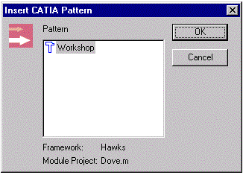

3.7.1 工具导航条
The wizard leads you through a series of panels wherein you are prompted for the caracteristics of the object you wish to create. After filling in each panel, you can move on to the next panel using the wizard navigation bar. When all the steps have been completed, you click on "Finish" to generate the component.
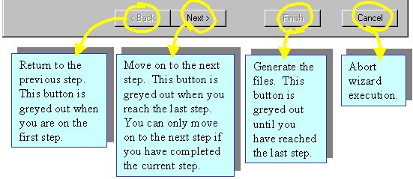

3.7.2 定义交互界面类
These are the steps to create a V5 workshop:
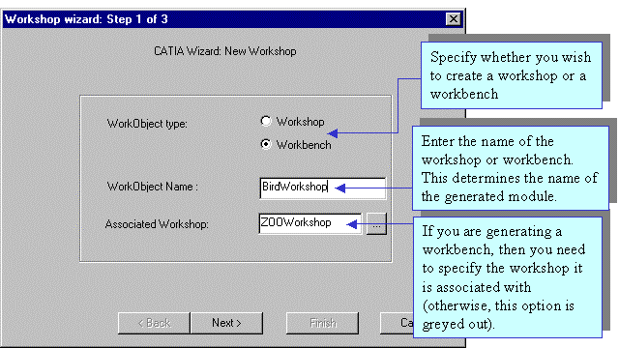
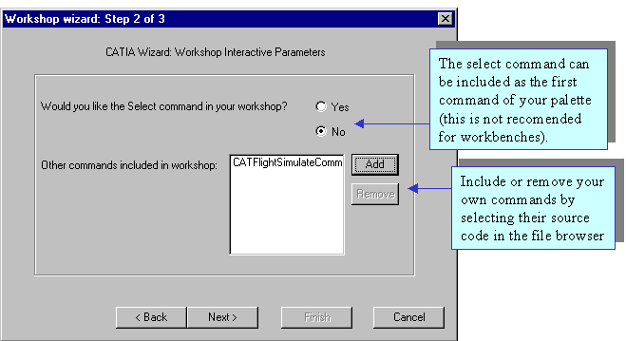
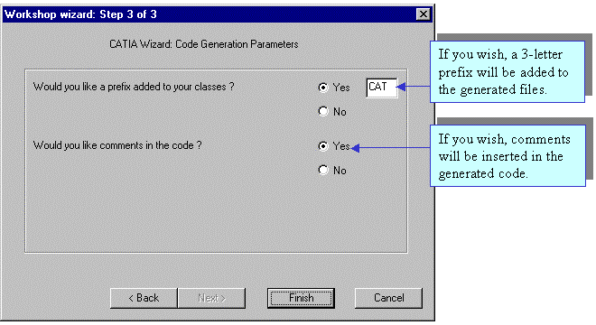

四、源代码编制

4.1 插件
详见《插件的开发方法》

4.2 命令
详见《命令的开发方法》

4.3 接口
详见《接口的开发方法》

4.4 对话框
详见《对话框的开发方法》

4.5 交互界面
详见《交互界面开发》

五、支撑框架设置（IdentiyCard.h）

5.1 作用
As almost all components (frameworks) are built upon others components, it is necessary
- To include at compile time the corresponding header files
- To reference at link time the corresponding libraries.
However the source files of a given component may include a lot of header files and, without the IdentityCard file, we must browse all the files to know the names of included header files and then find the names of the corresponding components.
The IdentityCard file synthesizes those relationships between frameworks in order to get quickly the prerequisite frameworks.
Warning: The IdentityCard file of any framework must at least contain a statement to set the System framework as a prerequisite framework up to its protected part, as follows:
AddPrereqComponent ("System", "Protected");
You must be aware that one user has often not all frameworks in his/her own workspace, and that most of the prerequisite frameworks he/she needs are located in others workspaces. Thanks to the IdentityCard file(s), tools like mkmk gain an easy way to determine and then access to prerequisite frameworks.
The figure below gives a summary of the use of Identity Card files. An application is made of components:
- Built or not upon other components.
- Using the CAA architecture each component is known as a framework possibly having prerequisite frameworks
- Prerequisite frameworks of a given framework are specified in its Identity Card file.
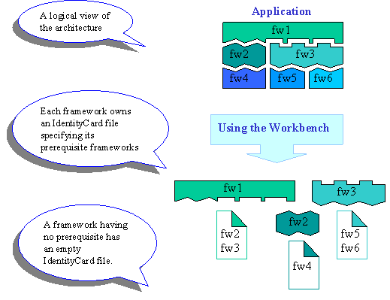
Note also that:
- Every framework has an Identity Card file which can be empty if it does not need other component to implement its services. This is not shown in the figure.
- Only frameworks that are directly used are specified in an Identity Card file.
Remember the notions of public and private parts of a component: you don't know how a framework is implemented, so you shouldn't know its own prerequisites.

5.2 保存位置
Every framework must have an Identity Card file, named IdentityCard.h.
This file is stored in directory IdentityCard, right under the framework root directory itself:.
This file allows the framework to declare (the list of) its prerequisite frameworks.
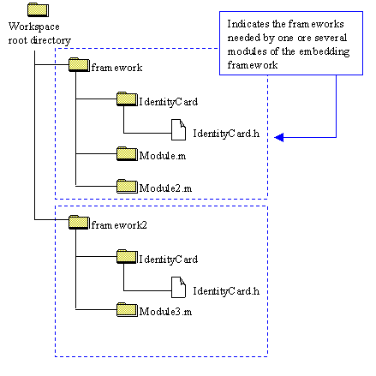
Conversely, to export one service a framework must just store the header file of its service in its PublicInterfaces directory.

5.3 内容
The IdentityCard.h file is a text file containing one line per prerequisite framework to declare.
The syntax of a line is:
AddPrereqComponent("<framework name>", Public);
In the following example, source themine.cpp in framework1/module1 needs header otherservice.h which is neither in module module1, nor in framework1, but in another framework named framework2. Thus, framework1 needs to declare framework2 as a prerequisite in its identity card:
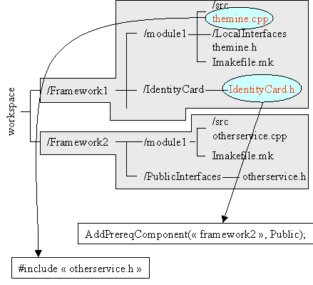
The previous schema gives an example of a prerequisite between code frameworks, you can also have:
- A prerequisite between an education framework (.edu) and a code framework - when the education framework contains code samples which need code frameworks to be implemented.
- A prerequisite between an education framework and others education frameworks - if the first framework contains documents which refer to documents managed in others frameworks.

六、编译与连接

6.1 确定支持框架

6.2 确定连接库文件
添加Imakefile.mk文件中所需库名

6.3 编译与连接

七、运行

7.1 资源提取

7.2 执行文件设置

7.3 运行

相关资料
[1] | Customize Developer Studio
[2] | Working with Developer Studio
[3] | Workbench Commands Mapping
[4] | Dialog builder features
[5] | 插件的开发方法
[6] | 命令的开发方法
[7] | 接口的开发方法
[8] | 对话框的开发方法
[9] | 交互界面的开发方法

